**CSSE3101 – ADVANCED WEB TECHNOLOGIES**

**STUDENT CENTERED ACTIVITY 4 – React Basics (Components, Routers, Hooks and Lists)**

**Create a currency converter React application using the following conversion values:**

**1 OMR = 2.60 US Dollar, 1 US Dollar = 0.39 OMR**

**Part 1 – Creating Components**

1. Create a new react app: **currencyconverter**
2. Create a folder **Components** and create the following components inside the created folder. Refer to the screenshots for the content for each component.
   1. Home

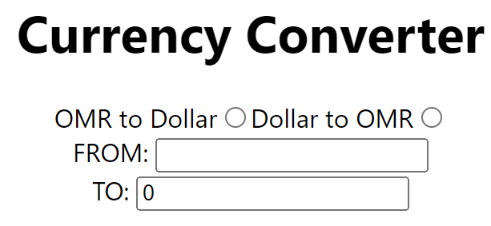

* 1. Currencies



**Part 2 – Creating Routes**

1. Update your App.js and use the React Router to create routes to the two components.
   1. /-render the home component
   2. /currencies-render the currencies component

**Part 3 – Creating Hooks**

1. In the Home component:
   1. Create state variables using the useState hook.
      1. **convertValue** – default value is zero,
      2. **type**– default value is zero
   2. Create a function that will update the value of the **convertValue** state variable when the user changes value in the **FROM** input text based on the conversion rates given. The convertValue must be dynamically reflected in the **TO** input text.

**Part 4 – Using list and map() function**

1. In the Currencies component:
   1. Create a list of currencies with at least 5 default values.
   2. Display these currencies in an ordered list when the page renders.